**1. Problem Statement:**

A Problem Statement for A Used Car Sales Report Focuses on Analyzing And Improving Used Car Pricing, Sales Strategy, And Market Transparency by Identifying Factors That Influence Vehicle Value and Sales Volume.

**2.Source Of Data:**

**2.1 Data Source From:** Www.Kaggle.Com

**2.2 Time Line:**

**2.3: Gitup Link:**

**3. Features Of Description:**

A Used Car Sales Report Details Key Metrics for Assessing Market Performance and Trends in The Pre-Owned Vehicle Industry. These Reports Can Be General Market Overviews or Specific, In-House Documents for A Car Dealership.

**4.Data Transformation And Cleaning:**

**4.1 Insight From The Raw Data:**

* **Identification**: The Report Includes Identifying Details For Each Vehicle, Such As The Year, Make, Model.
* **Specifications**: Features Like The Body Type (E.G., SUV, Sedan), Transmission Type (Automatic Or Manual), And Fuel Type (E.G., Petrol, Diesel, Or Electric) Are Categorized.

**4.2 Observation:**

* **Pricing**: The Report Includes The Vehicle's Selling Price, And Potentially The Original Market Value To Show The Difference.
* **Sales Figures**: Total Sales Volume (Units Sold) And Revenue (Total Value) Are Often Tracked Over Specified Time Periods.
* **Depreciation**: The Report May Analyze Depreciation Patterns For Different Makes And Models, Noting How A Car's Value Changes Over Time Based On Factors Like Age And Mileage.

**4.3 Possible Transformation Needed:**

* **Collect And Clean The Data:** Gather All Relevant Data Points, Such As Vehicle Make, Model, Year, Mileage, Sales Price, Fuel Type, Sales City, Body Type, Transmission, Register City And State, Source, Car Availability, Number Of Owners, Broker Quoter, Original Price, MI, And Down Payment. This Data Must Be Cleaned To Correct For Errors, Remove Duplicates, And Standardize Formats.

**5.Steps Done in The Cleaning Process:**

• Entire Data Are Lower Case It Changed to First Letter Capitalized.

• **Find and Replace**: Identified Inconsistent, Misspelling and Typos Error Are Using Find and Replacement Functions to Standardize the Text and Number Formats. Transmission Column, Register City and State.

**• Examples**: Manual -> 0, Automatic ->1, Trichirappalli _> Trichy And New Delhi _> Delhi.

• **IF_ISBLANK**: Transmission column missing values changed effectively using if(isblank) function. (e.g) Transmission column, car Availability, sales price, Broker quoter, EMI, source.

• **IF Functions**: In Broker quoter columns “0” Values are change in “₹ 2,500” using IF Function.

**• DATE: AD_ON**: Date with time format changed to short date.

Data Cleaning was done with EXCEL.

**6.Power Query:** All required data transformation done in Power Query.

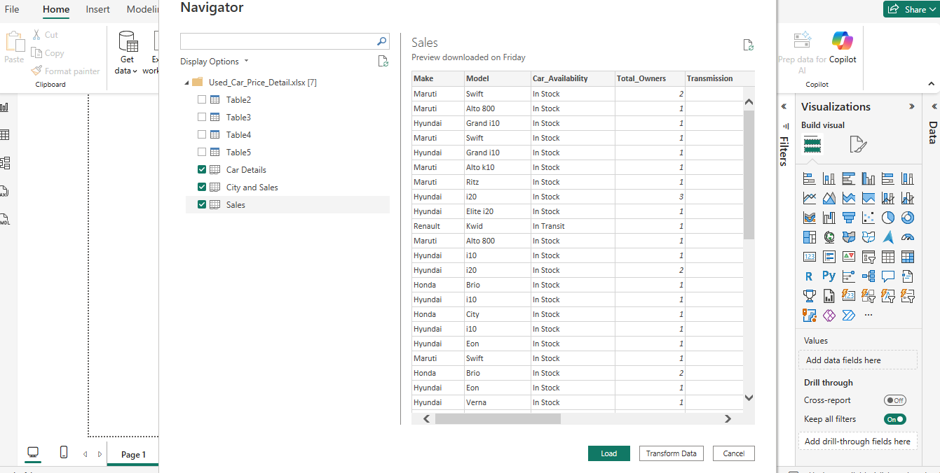

**7.Power BI:** Creating a report with interactive data visualizations. The data using a drag-and-drop canvas and hundreds of modern data visuals from Microsoft Power BI custom visuals framework.

**7.1: Overall Sales Report:**

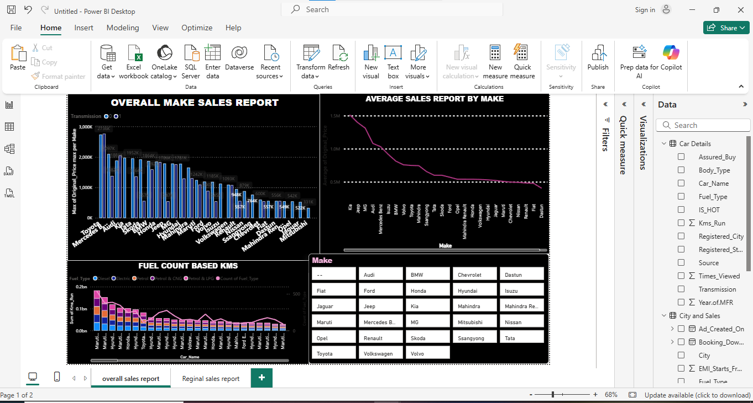

**7.2: Reginal Sales Report:**

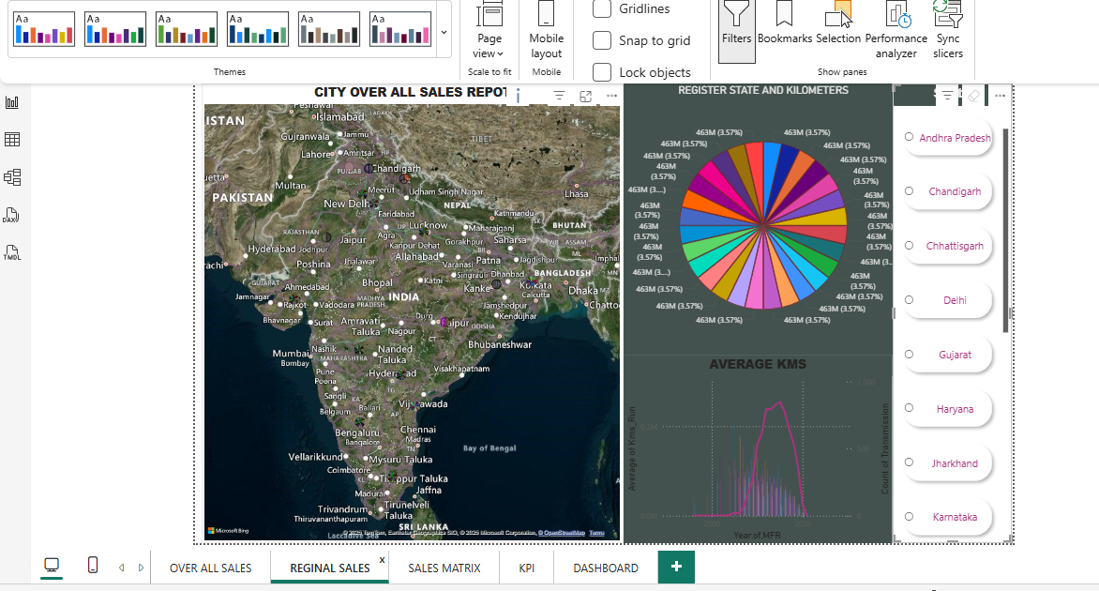

**7.3 Sales Matrix:**

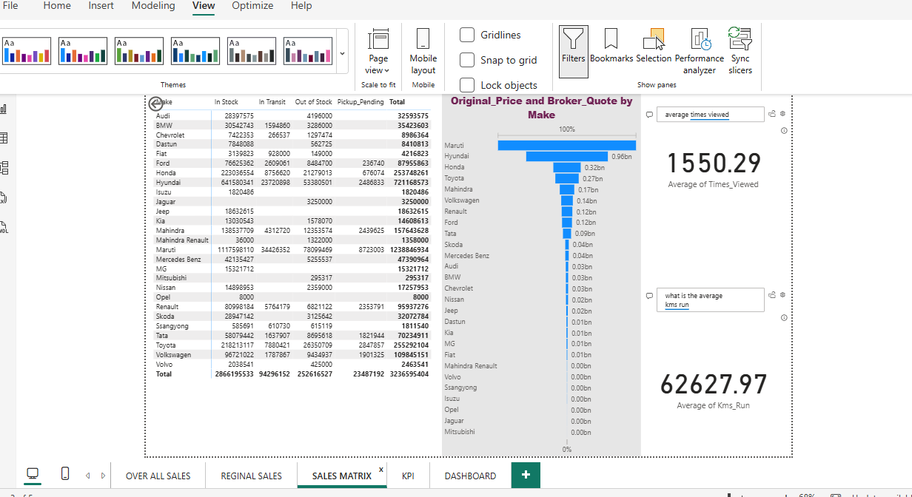

**7.4 KPI:**

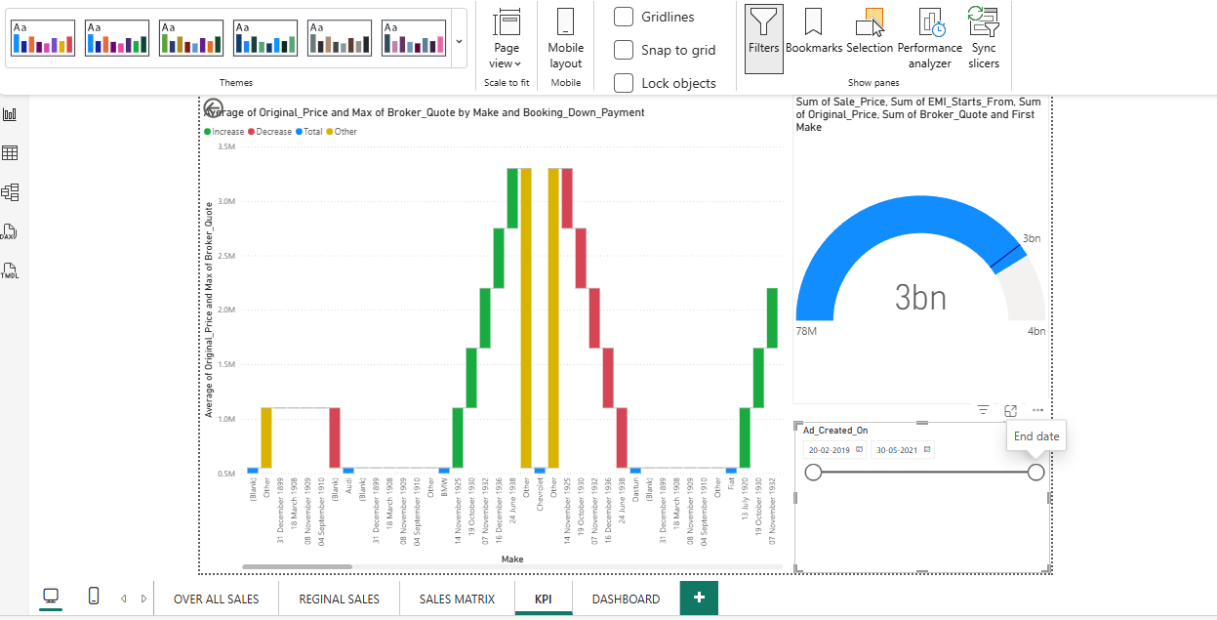

**8. Dashboard Report:**

